3rd Grade Supply List

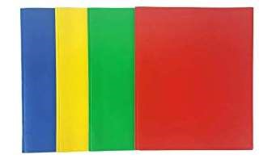  Plastic or laminated mead double pocket folders  6 two-pocket folders  (blue, green, red, and yellow) \\ | 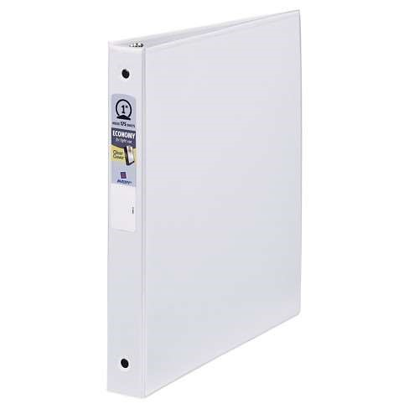  1 inch binder
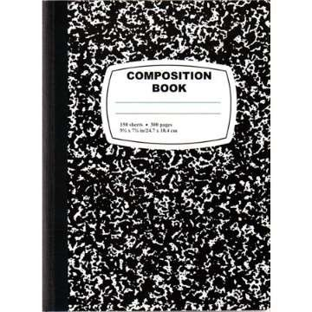  4 Mead marble composition notebooks  (wide-ruled) | 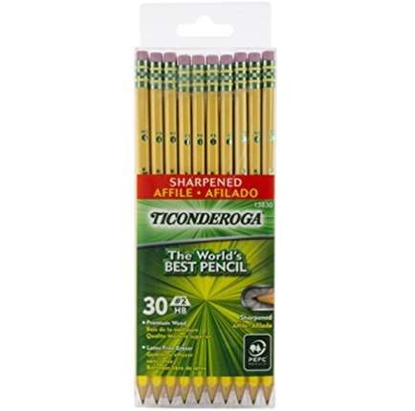  5 boxes of sharpened pencils Ticonderoga (12 count)
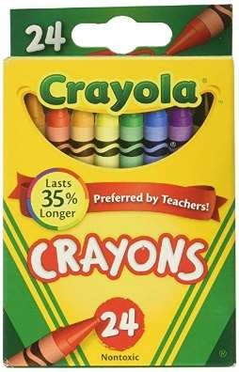  1 box Crayola crayons  (24 count) | 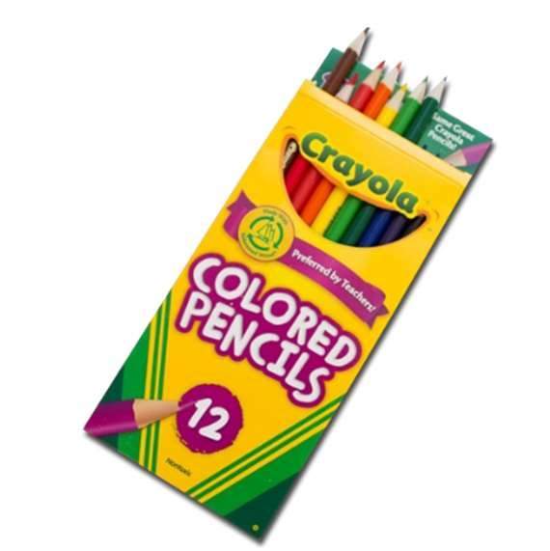  1 box Crayola-colored pencils (sharpened, 12 count)

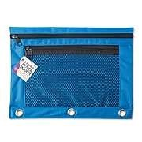  1 pencil pouch | 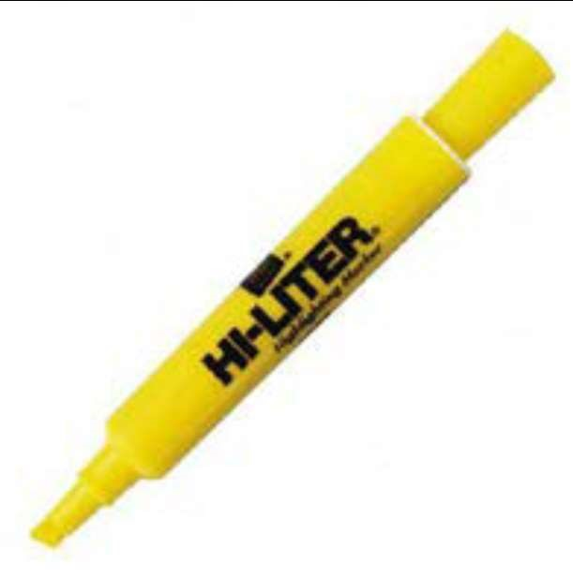  2 yellow highlighters
1 pair Fiskars scissors (5 inch) | 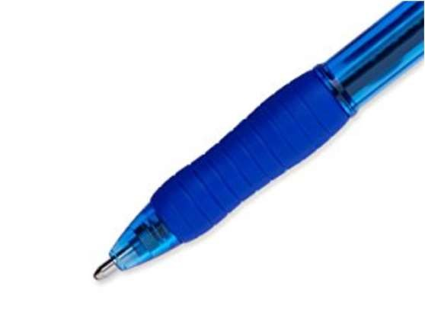  2 ballpoint blue pens
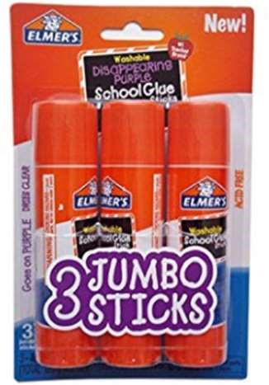  3 LARGE glue sticks | 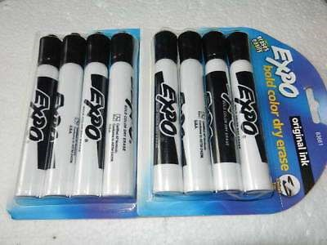  8 Expo brand, low-odor dry erase markers  (thick point style)
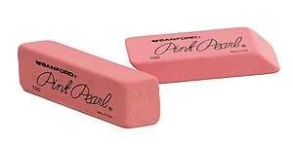  2 pink erasers | 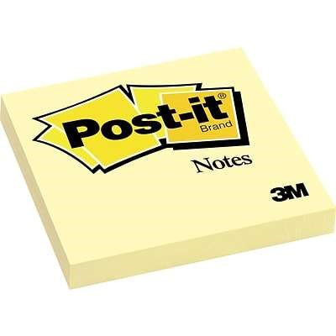  2 pack of Post it Notes

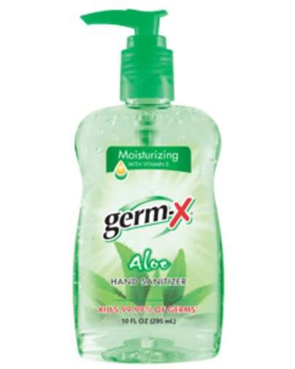  1 bottle of hand sanitizer | 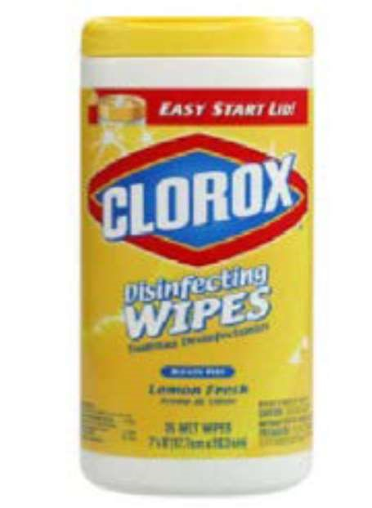  2 tubs of Clorox wipes
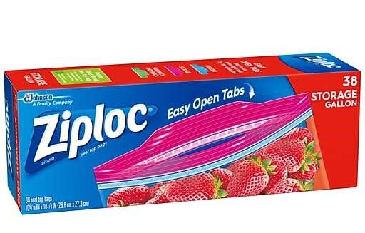  1 box of gallon Ziploc bags | 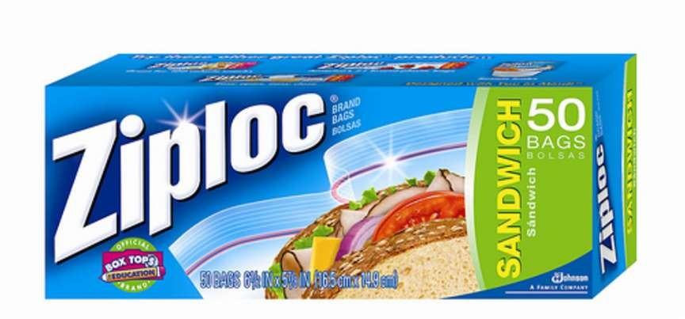  1 box of sandwich Ziploc bags
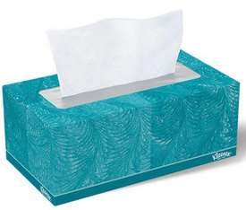  4 boxes Kleenex tissues | 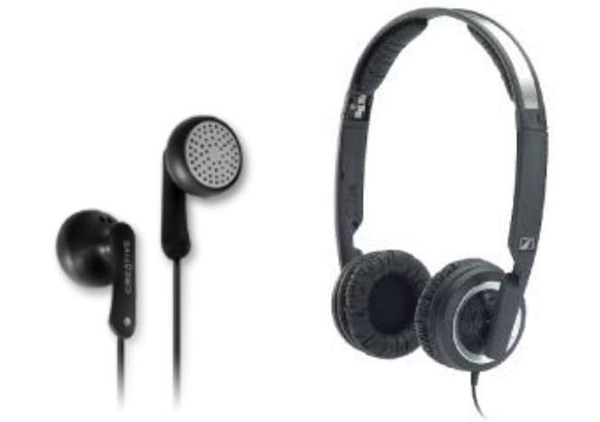  earphones or headsets  *This is very important because we use computers a lot in 3rd grade*

Thanks so much! 😊

